CONT933 Module 2 Culminating Task Template
PART 1: Reflect on the SAMR Model
Think about a lesson that you’ve created or that you will create in the near future.
If you could use a technology tool to further the learning of your student, what would it look like? Sound like? Feel like … for the student and for you?
When and how could you move that lesson to the next level of learning?
Activity Name:
Grade Level: | 4
Curriculum Content (Mathematics): | Big Idea:  - Development of computational fluency and multiplicative thinking requires analysis of patterns and relations in multiplication and division.  Curricular Content  - multiplication and division facts to 100 (introductory computational strategies)  curricular competencies  - Develop mental math strategies and abilities to make sense of quantities  - Use technology to explore mathematics  - Model mathematics in contextualized experiences  - Visualize to explore mathematical concepts  - Communicate mathematical thinking in many ways  - Use mathematical vocabulary and language to contribute to mathematical discussions  - Explain and justify mathematical ideas and decisions  - Represent mathematical ideas in concrete, pictorial, and symbolic forms
Curriculum Content (Technology): | The choice of technology and tools depends on the task. ( big idea)  Curricular competencies  - Identify the skills required for a task and develop those skills as needed  - Use familiar tools and technologies to extend their capabilities when completing a task  - Choose appropriate technologies to use for specific tasks  - Demonstrate a willingness to learn new technologies as needed
Level on SAMR Model: | Substitution

Description of Original Activity (point-form or sentences):
In the original activity students would represent multiplication using at least three of the six strategies taught and practiced in class. Students would then take pictures of their work and upload the images to My Blueprint.

PART 2: Now re-create part of the lesson (from Part 1) to reflect a change on the SAMR Model:
Curriculum Content (Mathematics): | Big Idea:  - Development of computational fluency and multiplicative thinking requires analysis of patterns and relations in multiplication and division.  Curricular Content  - multiplication and division facts to 100 (introductory computational strategies)  curricular competencies  - Develop mental math strategies and abilities to make sense of quantities  - Use technology to explore mathematics  - Model mathematics in contextualized experiences  - Visualize to explore mathematical concepts  - Communicate mathematical thinking in many ways  - Use mathematical vocabulary and language to contribute to mathematical discussions  - Explain and justify mathematical ideas and decisions  Represent mathematical ideas in concrete, pictorial, and symbolic forms
Curriculum Content (Technology): | The choice of technology and tools depends on the task. ( big idea)  Curricular competencies  - Identify the skills required for a task and develop those skills as needed  - Use familiar tools and technologies to extend their capabilities when completing a task  - Choose appropriate technologies to use for specific tasks  Demonstrate a willingness to learn new technologies as needed
NEW Level on SAMR: | Modification

Description of New Activity (point-form or sentences):
Students will create instructional videos for other students using clips on the iPads to explain how to use four different strategies to solve multiplication problems. Students will share their videos on the math channel in our class team as well as posting them to their My Blueprint portfolio. When posting them to teams students will be able to view each others work.

SAMR Model
Class Task | Substitution | Augmentation | Modification | Redefinition
Note taking | Notes taken using IOS Notes | Students choose their own notes app | All students use Notability for all notes | Teachers have access to all student’s notes
Research | Using Safari to copy and paste information | Bookmark and share notes using the share button | Download and annotate with Notability | Collaborative Mindmaps
Presentation | Make a keynote presentation on the iPad | Demonstrate understanding with Explain Everything | Combine audio, video, and text in Movie Presentation | Nearpod Presentation
File sharing | Sent by email every lesson | Shared Dropbox folder | Showbie | iTunes U
Reading | Open PDF from email | Use dictionary and search document | Annotating documents in Notability and iBooks | Interactive iBooks
Assessment | Google form test | Google form test with automatic marking script | Creative projects with Strip Designer, Showme, and iMovie | Creative assignments with audio feedback in Showbie

How did you use the SAMR model to enhance this activity? (write a short paragraph)
When planning this activity I applied the SAMR model, however I leaned more on the PIC RAT model. I prefer the PIC RAT matrix which looks at both what students do with the technology and how the technology being used. My activity is a Creative one in that student are generating content and Transformative because they are using the iPad and the clips app. On the SAMR model this activity sits between a modification and a redefinition, while aspects of the task would not be possible without the technology the idea of having students teach each other or explain it to someone else is not new. I am inclined to put this more firmly in the modification category because the technology does allow some improvement and using Clips allows students to record their voice as well as demonstrate their understanding visually. Using the SAMR model or PIC RAT matrix allows me to focus on what my intention behind using the technology is and if the technology is necessary for that lesson. By considering what the role of technology in the lesson is I can make sure that I am using it to help my students be active learners and content creators rather than passive consumers. For me having my students use of technology focused on creating meaningful content and using technology to share their understanding, thoughts, opinions and knowledge is key. I would like to move this task towards redefinition and think that having students be able to collaborate digitally would be the next step, I am looking for tools that will be FOIPPA compliant and allow my students to do so.

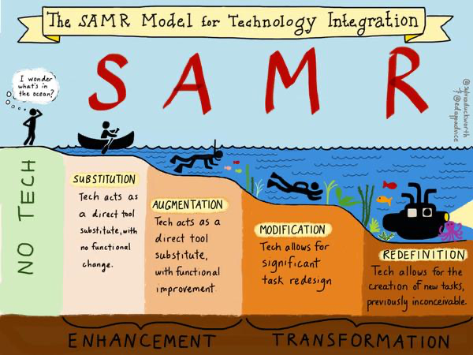
(Duckworth, 2015)
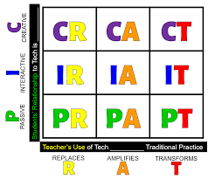

(Forsyth County Schools, n.d.)

Bibliography
Duckworth, S. (2015, April 5). the SAMR Model.
Forsyth County Schools. (n.d.). Retrieved from https://www.forsyth.k12.ga.us/Page/52613

